Chemistry 115 Name
Dr. Cary Willard
Quiz 2A (20 points) September 8, 2009

All work must be shown to receive credit. Be sure to give your answers to the correct number of significant figures.

- (5 points) Use dimensional analysis to determine the number of dimes that are equal to 62.0 quarters.

- (5 points) A barrel of orange juice contains 2.15 kL of orange juice. How many mL of orange juice are in the barrel?

- (5 points) My dog has a mass of 36.8 kg. How many lb does my dog weigh?

- (5 points) The ruler below is calibrated to measure centimeters. How long is the line in cm?

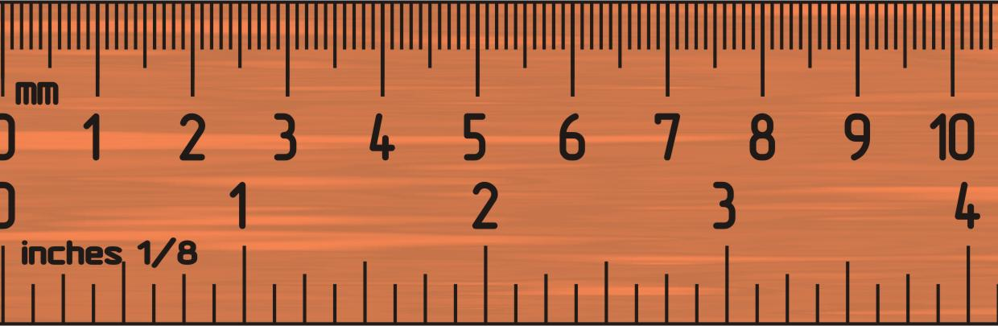
Chemistry 115 Name
Dr. Cary Willard
Quiz 2B (20 points) September 8, 2009

All work must be shown to receive credit. Be sure to give your answers to the correct number of significant figures.

- (5 points) Use dimensional analysis to determine the number of dimes that are equal to 54.0 quarters.

- (5 points) A barrel of orange juice contains 3.72 kL of orange juice. How many mL of orange juice are in the barrel?

- (5 points) My dog has a mass of 42.8 kg. How many lb does my dog weigh?

- (5 points) The ruler below is calibrated to measure centimeters. How long is the line in cm?

Chemistry 115 Name
Dr. Cary Willard
Quiz 2A (20 points) September 9, 2009

All work must be shown to receive credit. Be sure to give your answers to the correct number of significant figures.

- (5 points) Use dimensional analysis to determine the number of dimes that are equal to 36.0quarters.

- (5 points) A barrel of orange juice contains 1.74 kL of orange juice. How many mL of orange juice are in the barrel?

- (5 points) My dog has a mass of 61.4 kg. How many lb does my dog weigh?

- (5 points) The ruler below is calibrated to measure centimeters. How long is the line in cm?

Chemistry 115 Name
Dr. Cary Willard
Quiz 2B (20 points) September 9, 2009

All work must be shown to receive credit. Be sure to give your answers to the correct number of significant figures.

- (5 points) Use dimensional analysis to determine the number of dimes that are equal to 22.0 quarters.

- (5 points) A barrel of orange juice contains 4.29 kL of orange juice. How many mL of orange juice are in the barrel?

- (5 points) My dog has a mass of 29.5 kg. How many lb does my dog weigh?

- (5 points) The ruler below is calibrated to measure centimeters. How long is the line in cm?

Chemistry 115 Name
Dr. Cary Willard
Quiz 2A (20 points) September 10, 2009

All work must be shown to receive credit. Be sure to give your answers to the correct number of significant figures.

- (5 points) Use dimensional analysis to determine the number of dimes that are equal to 84.0 quarters.

- (5 points) A barrel of orange juice contains 6.93 kL of orange juice. How many mL of orange juice are in the barrel?

- (5 points) My dog has a mass of 12.8 kg. How many lb does my dog weigh?

- (5 points) The ruler below is calibrated to measure centimeters. How long is the line in cm?

Chemistry 115 Name
Dr. Cary Willard
Quiz 2B (20 points) September 10, 2009

All work must be shown to receive credit. Be sure to give your answers to the correct number of significant figures.

- (5 points) Use dimensional analysis to determine the number of dimes that are equal to 38.0 quarters.

- (5 points) A barrel of orange juice contains 4.87 kL of orange juice. How many mL of orange juice are in the barrel?

- (5 points) My dog has a mass of 47.2 kg. How many lb does my dog weigh?

- (5 points) The ruler below is calibrated to measure centimeters. How long is the line in cm?

